How Many Times Can Cells Be Re-Programmed
Asian Scientist Newsroom | March 11, 2015
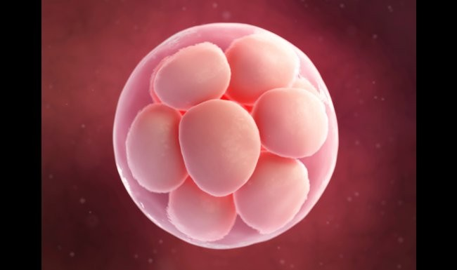
AsianScientist (Mar. 11, 2015) - Scientists have shown that mice generated from induced pluripotent stem (iPS) cells and tetraploid blastocyst complementation can tolerate the accumulation of somatic mutations for up to six generations. However, their work published in Nature Communications also showed that subsequent generations of all-iPS mice had fewer pups born alive. iPS cells are a type of pluripotent stem cell that can be generated directly from adult cells via introduction of four specific genes encoding transcription factors. There have been concerns that reprogramming mediated by the four transcription factors could induce or enhance mutations in the iPS cells, thereby reducing their safety and development potential. To address these issues, a team of researchers led by Professor Cai Jun from the Beijing Institute of Genomics of the Chinese Academy of Sciences combined a sequential reprogramming system with whole genome sequencing. Their study suggests that single nucleotide variations (SNVs) accumulated in the course of sequential reprogramming accounted for the gradual decrease in viability of iPS-derived mice. While first to third generation all-iPS mice could develop into fertile adults, fourth and fifth generation mice survived only up to four weeks and two days, respectively. Combined MeDIP-seq and RNA-seq results indicated that the decreased viability was unrelated with epigenetic effects. Further investigation revealed that SNVs accumulated throughout the sequential process. Functional annotation of these SNVs demonstrated that these mutations would cause developmental failures in mice, and corresponding abnormal phenotypes were supported by histopathological examination. The origins of these accumulated SNVs were evaluated via droplet digital PCR (ddPCR), and the results showed that about two-thirds of the SNVs pre-existed in the all-iPSC mouse tissues which generated during development, rather than merely in iPSC induction. Another interesting observation from this study was the recurrent loss of retrotransposon in iPS cells, a pattern that recurred in other pluripotent stem cells including embryonic stem cells and blastocysts. The deleted retrotransposons were regained in differentiated cells after differentiation either in vitro and vivo. However, the reason of unique loss of retrotransposon in pluripotent stem cells requires further investigations. This study provides information to better understand the association between gene mutations and developmental effect, essential knowledge for screening pre-clinical bio-safety of iPS cells. The article can be found at: Gao et al. (2015) Unique Features of Mutations Revealed by Sequentially Reprogrammed Induced Pluripotent Stem Cells.

